Exercise 1:
In order to adjust to the screen of mobile device, we should add one line in the code, it is
<meta name='viewport' content='width=device-width, initial-scale=1'/>
And the followings are the test result in AVD:

The screen capture of Books.php

Here is the capture of Books.php read another xml file, we can see it display with year information

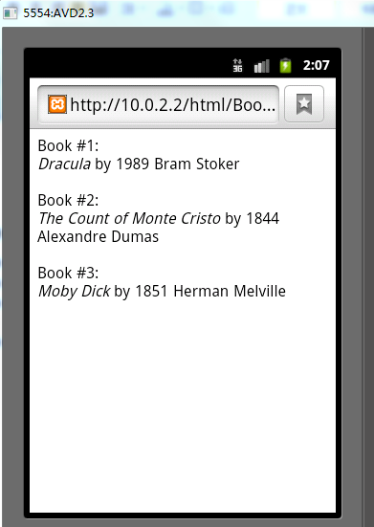
Here is the Books2.php


Own exercise
in our own exercise we create a more complex xml file and use php to display it
Here is the result capture
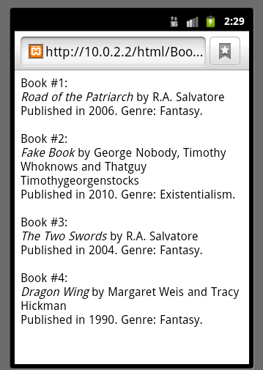

XML Schema & XForms
In this exercise, it just need a page to test file, so in android it is not needed to do
Using XML in a Database
In this exercise, we are going to use the XML in database and read the information form the XML in database.
Here is the test result of xmlDatabase1.php
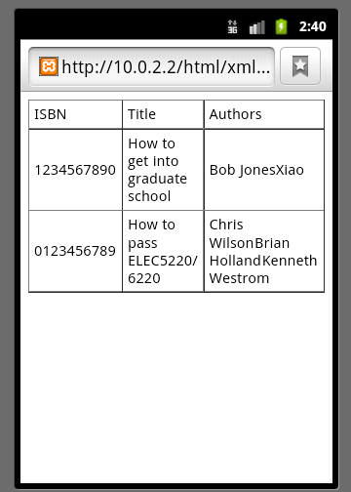
Here is the test result of xmlDatabase2.php
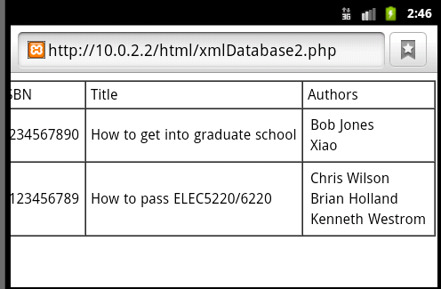

Here is the test result of xmlDatabase3.php
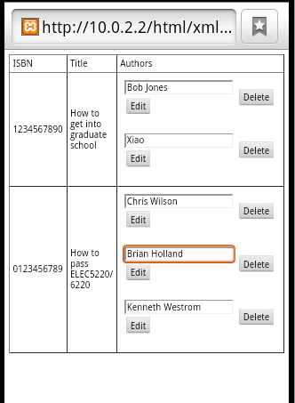
And we change one author to Dr. Wu
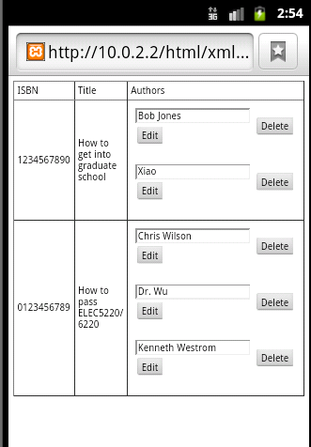
And we check the result by using the xmlDatabase2.php
It show as follows
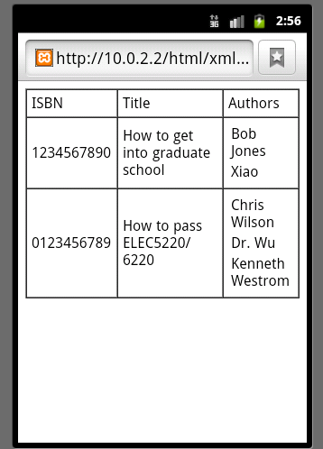
As it shows the database has been changed

And in xmlDatabase4_modify.php, we modify several bug and add new function
We add a new author to the database
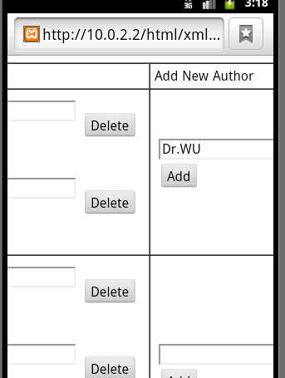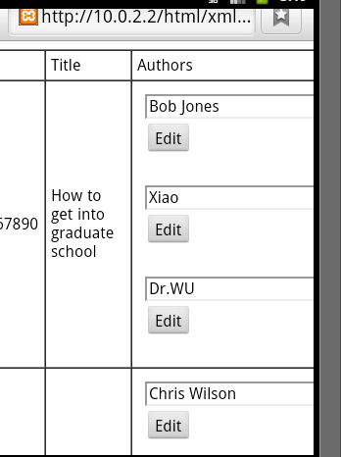
And we also can use previous php page to check the result, it likes this
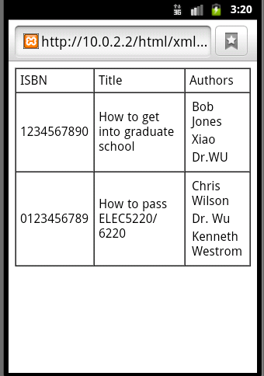
We can see, the database have been changed

And in next page, we add a search function
The original page
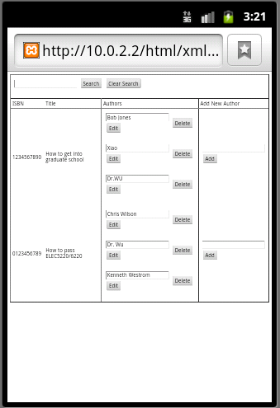

And if we search Wu, because both book have author Dr. Wu, so it displaying likes this
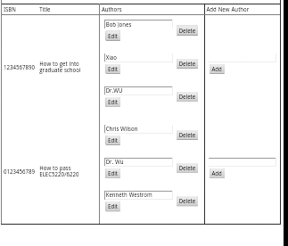
And if we search Xiao, it likes this
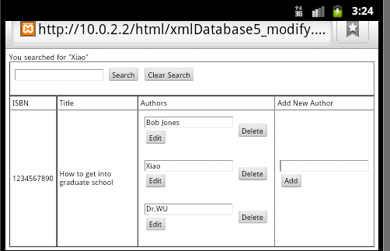

Homework
The original page is like this
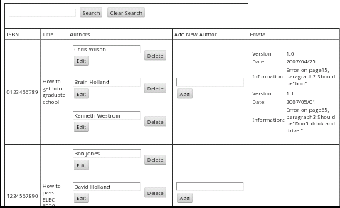
And we search Chris
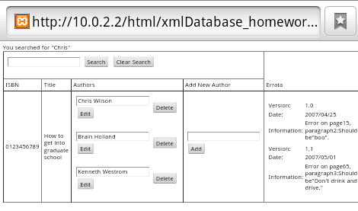

Own exercise

In own exercise we create a database contain the information about mobile phone and a search function, the original page likes this
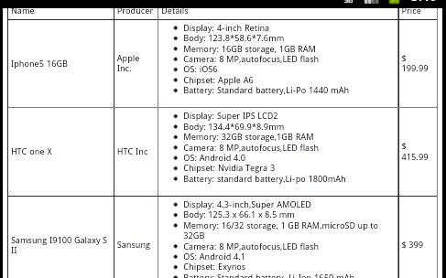

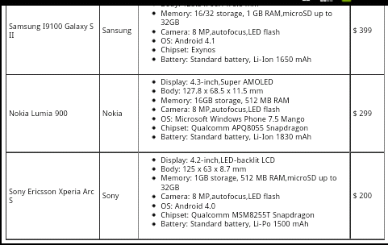
And if we search for Nokia
